[Note: Please delete sections 1, 2, & 3 as needed based on what features you have purchased. If you are unsure, please contact the deployment team at deployment@masternaut.com or your account manager]

What is the in-cab coach?
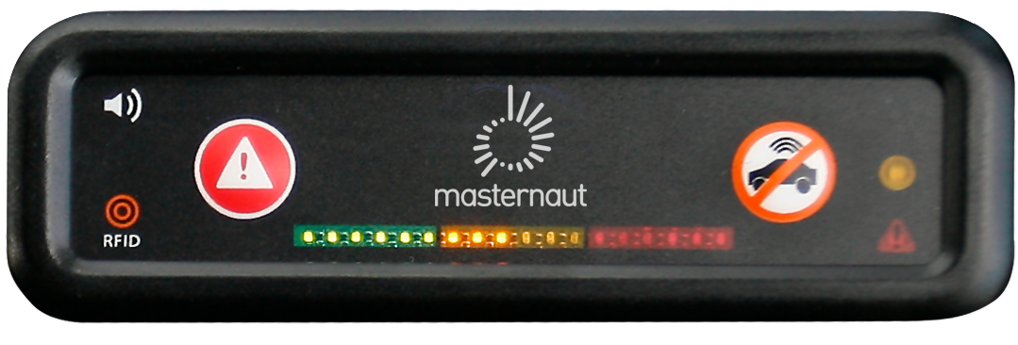
This little device is designed to keep you safe. It is a coach that sits on your dashboard and does the following:

- Driver Identification (if applicable)
- Privacy Button (if applicable)
- Driver Feedback (if applicable)

Any questions or problems? Please contact:

[Insert Appropriate Contact]

Driver Feedback
What will the in-cab coach do?
The in-cab coach will provide audio and visual feedback on the 4 following harsh driving events:
- Acceleration
- Braking
- Speeding
- Idling
What do the colours and beeps represent?

Amber | Red
Harsh Driving (e.g., harsh acceleration / braking, moderate speeding, and idling) | Extreme Driving (e.g., slamming on the brakes, significant speeding)
Single Beep | Constant Beep

Driving style events are reported centrally into a series of reports to profile drivers Green / Amber / Red based on events per hour. These reports will be used to improve driver safety.

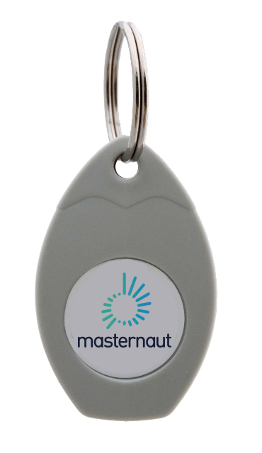
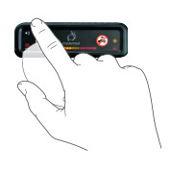
Driver Identification

How do I log in every day?
- Present the key to the in-cab coach before you
turn the ignition on
- The reader will acknowledge the key with a rapid flash of the orange LED
- Start your ignition

If you start the engine and hear the buzzer sound, you have not logged in correctly. Turn off your engine and go back to Step 1. Please follow this process each time you switch on your ignition. Do not lend or swap your tag with another driver.
What happens if I don’t log in?
The in-cab coach’s notification light will flash & bleep to alert you to log in.
What should I do if I lose my key?
Please contact your line manager for a replacement.

Privacy Button

In private mode, your location is not visible to others on the Masternaut Connect map or in any reports. The number of miles driven while in private mode is available via reports for tax purposes.
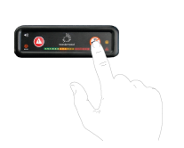
How do I go into private mode?
In order to activate private mode, please follow these instructions:
- Your vehicle engine must be fully off
- Press the private button
- You will see an amber notification light blinking to the right of the private button
- Switch the engine on
- The amber notification light will switch from flashing to fixed: you have successfully entered private mode.

As long as the amber notification light is on, you are in private mode. Normal business mode will be activated the next time you start your engine, if you don’t press the privacy button.

